**Chapter 2- Investigating Frost Response, Rootstock-Dependent Cold Tolerance, and Floral Bud Mortality in Apple Cultivars through Transcriptomic Insights**

**Supplementary materials**

Additional Tables

**Table S1:** Gene Ontology Enrichment Analysis of Hub Genes Associated with Frost Tolerance in Apple Rootstocks.

|  |  |  |  |  |  |
| --- | --- | --- | --- | --- | --- |
|  |  |  | **Pathway** | | |
| **Gene** | **Description** | **Module** | **Response to Cold** | **Response to ABA** | **Response to water deprivation** |
| MD07G1151700 | Symbols:  | Integrase-type DNA-binding superfamily protein | chr1:104731-105309 REVERSE LENGTH=192 | ME 6 |  |  |  |
| MD15G1344900 | Symbols: ATAF1, ANAC002 | NAC (No Apical Meristem) domain transcriptional regulator superfamily protein | chr1:268471-269514 FORWARD LENGTH=289 | ME 7 |  |  |  |
| MD03G1287000 | Symbols: NLA, BAH1 | SPX (SYG1/Pho81/XPR1) domain-containing protein | chr1:635474-637083 FORWARD LENGTH=335 | ME 7 |  |  |  |
| MD16G1206500 | Symbols: SHY2, IAA3 | AUX/IAA transcriptional regulator family protein | chr1:1128564-1129319 REVERSE LENGTH=189 | ME 6 |  |  |  |
| MD03G1269600 | Symbols:  | Eukaryotic aspartyl protease family protein | chr1:1762843-1766150 REVERSE LENGTH=485 | ME 6 |  |  |  |
| MD04G1202300 | Symbols: SRC2, (AT)SRC2 | soybean gene regulated by cold-2 | chr1:2927767-2928741 FORWARD LENGTH=324 | ME 7 |  |  |  |
| MD16G1101100 | Symbols:  | beta-1,4-N-acetylglucosaminyltransferase family protein | chr1:4433973-4435552 FORWARD LENGTH=392 | ME 7 |  |  |  |
| MD16G1048100 | Symbols: GATL3 | galacturonosyltransferase-like 3 | chr1:4528965-4530002 REVERSE LENGTH=345 | ME 7 |  |  |  |
| MD05G1042600 | Symbols: WBC11, ABCG11, DSO, COF1, ATWBC11 | white-brown complex homolog protein 11 | chr1:6142870-6145894 FORWARD LENGTH=703 | ME 9 |  |  |  |
| MD13G1184700 | Symbols:  | Calcium-binding EF-hand family protein | chr1:6268273-6268785 REVERSE LENGTH=170 | ME 7 |  |  |  |
| MD14G1235700 | Symbols:  | Calcium-binding EF-hand family protein | chr1:6268273-6268785 REVERSE LENGTH=170 | ME 7 |  |  |  |
| MD06G1236500 | Symbols: EPR1, RVE7 | Homeodomain-like superfamily protein | chr1:6306196-6307640 REVERSE LENGTH=346 | ME 7 |  |  |  |
| MD12G1022300 | Symbols:  | Basic-leucine zipper (bZIP) transcription factor family protein | chr1:6751953-6753959 REVERSE LENGTH=471 | ME 7 |  |  |  |
| MD02G1140100 | Symbols: LTI29, LTI45, ERD10 | Dehydrin family protein | chr1:7088235-7089107 REVERSE LENGTH=259 | ME 7 |  |  |  |
| MD16G1108700 | Symbols:Ê | HXXXD-type acyl-transferase family protein | chr1:8658190-8659497 REVERSE LENGTH=435 | ME 9 |  |  |  |
| MD16G1109300 | Symbols:Ê | HXXXD-type acyl-transferase family protein | chr1:8658190-8659497 REVERSE LENGTH=435 | ME 9 |  |  |  |
| MD09G1062800 | Symbols:  | FUNCTIONS IN: molecular_function unknown; INVOLVED IN: biological_process unknown; LOCATED IN: cellular_component unknown; EXPRESSED IN: 24 plant structures; EXPRESSED DURING: 15 growth stages; BEST Arabidopsis thaliana protein match is: ELM2 domain-containing protein (TAIR:AT2G03470.1); Has 161 Blast hits to 161 proteins in 17 species: Archae - 0; Bacteria - 0; Metazoa - 1; Fungi - 4; Plants - 156; Viruses - 0; Other Eukaryotes - 0 (source: NCBI BLink). | chr1:9185620-9187213 FORWARD LENGTH=493 | ME 7 |  |  |  |
| MD13G1084300 | Symbols:  | Domain of unknown function (DUF23) | chr1:9449812-9451539 REVERSE LENGTH=575 | ME 6 |  |  |  |
| MD16G1121700 | Symbols:  | unknown protein; FUNCTIONS IN: molecular_function unknown; INVOLVED IN: biological_process unknown; EXPRESSED IN: 25 plant structures; EXPRESSED DURING: 15 growth stages; Has 44 Blast hits to 44 proteins in 12 species: Archae - 0; Bacteria - 0; Metazoa - 0; Fungi - 0; Plants - 44; Viruses - 0; Other Eukaryotes - 0 (source: NCBI BLink). | chr1:9481788-9482576 FORWARD LENGTH=142 | ME 7 |  |  |  |
| MD15G1071400 | Symbols: STZ, ZAT10 | salt tolerance zinc finger | chr1:9648302-9648985 REVERSE LENGTH=227 | ME 7 |  |  |  |
| MD09G1137100 | Symbols: HSR8, MUR4, UXE1 | NAD(P)-binding Rossmann-fold superfamily protein | chr1:10855496-10857970 FORWARD LENGTH=419 | ME 6 |  |  |  |
| MD06G1002100 | Symbols: ATBZIP60, BZIP60 | basic region/leucine zipper motif 60 | chr1:16136062-16137459 REVERSE LENGTH=295 | ME 7 |  |  |  |
| MD05G1021600 | Symbols: emb1075 | Pyridoxal phosphate (PLP)-dependent transferases superfamily protein | chr1:16486534-16488298 REVERSE LENGTH=482 | ME 7 |  |  |  |
| MD15G1081800 | Symbols: ABF2, AREB1, ATAREB1 | abscisic acid responsive elements-binding factor 2 | chr1:17165420-17167415 REVERSE LENGTH=416 | ME 7 |  |  |  |
| MD15G1080900 | Symbols:  | unknown protein; FUNCTIONS IN: molecular_function unknown; INVOLVED IN: biological_process unknown; LOCATED IN: plasma membrane; EXPRESSED IN: 22 plant structures; EXPRESSED DURING: 13 growth stages; BEST Arabidopsis thaliana protein match is: unknown protein (TAIR:AT5G42860.1); Has 258 Blast hits to 242 proteins in 39 species: Archae - 0; Bacteria - 11; Metazoa - 10; Fungi - 14; Plants - 198; Viruses - 17; Other Eukaryotes - 8 (source: NCBI BLink). | chr1:17191502-17192870 FORWARD LENGTH=342 | ME 7 |  |  |  |
| MD13G1147300 | Symbols:  | Protein phosphatase 2C family protein | chr1:17720064-17721698 REVERSE LENGTH=383 | ME 7 |  |  |  |
| MD10G1208800 | Symbols: HAP5B, ATHAP5B, NF-YC2 | nuclear factor Y, subunit C2 | chr1:21025118-21025717 FORWARD LENGTH=199 | ME 6 |  |  |  |
| MD04G1190900 | Symbols: AtGolS2, GolS2 | galactinol synthase 2 | chr1:21207620-21209291 FORWARD LENGTH=335 | ME 7 |  |  |  |
| MD17G1044300 | Symbols: CW14 | Protein of unknown function (DUF1336) | chr1:21920099-21922670 FORWARD LENGTH=492 | ME 7 |  |  |  |
| MD06G1177100 | Symbols:  | ARM repeat superfamily protein | chr1:22198403-22200463 FORWARD LENGTH=686 | ME 7 |  |  |  |
| MD10G1299600 | Symbols:  | disease resistance protein (TIR class), putative | chr1:22508831-22512122 REVERSE LENGTH=808 | ME 7 |  |  |  |
| MD16G1042400 | Symbols:  | unknown protein; FUNCTIONS IN: molecular_function unknown; INVOLVED IN: biological_process unknown; LOCATED IN: chloroplast; EXPRESSED IN: 22 plant structures; EXPRESSED DURING: 13 growth stages; BEST Arabidopsis thaliana protein match is: unknown protein (TAIR:AT1G13390.2); Has 125 Blast hits to 125 proteins in 18 species: Archae - 0; Bacteria - 0; Metazoa - 0; Fungi - 0; Plants - 125; Viruses - 0; Other Eukaryotes - 0 (source: NCBI BLink). | chr1:25693926-25694946 FORWARD LENGTH=183 | ME 7 |  |  |  |
| MD13G1070200 | Symbols: ATEXPA1, EXP1, AT-EXP1, ATEXP1, ATHEXP ALPHA 1.2, EXPA1 | expansin A1 | chr1:26142034-26143051 FORWARD LENGTH=250 | ME 7 |  |  |  |
| MD13G1073500 | Symbols:  | TCP family transcription factor  | chr1:26216449-26217426 FORWARD LENGTH=325 | ME 7 |  |  |  |
| MD13G1028100 | Symbols:  | unknown protein; FUNCTIONS IN: molecular_function unknown; INVOLVED IN: biological_process unknown; LOCATED IN: endomembrane system; BEST Arabidopsis thaliana protein match is: unknown protein (TAIR:AT2G12400.1); Has 173 Blast hits to 169 proteins in 21 species: Archae - 0; Bacteria - 0; Metazoa - 3; Fungi - 0; Plants - 165; Viruses - 0; Other Eukaryotes - 5 (source: NCBI BLink). | chr1:26818244-26820852 FORWARD LENGTH=557 | ME 7 |  |  |  |
| MD10G1003000 | Symbols:  | Galactose-binding protein | chr1:26892214-26894166 REVERSE LENGTH=596 | ME 7 |  |  |  |
| MD15G1186700 | Symbols: TFIIIA | transcription factor IIIA | chr1:27115082-27117228 FORWARD LENGTH=412 | ME 6 |  |  |  |
| MD06G1233800 | Symbols:  | alpha/beta-Hydrolases superfamily protein | chr1:27629266-27632486 FORWARD LENGTH=463 | ME 7 |  |  |  |
| MD15G1227900 | Symbols: HMG1, HMGR1, AtHMGR1 | hydroxy methylglutaryl CoA reductase 1 | chr1:28695801-28698206 FORWARD LENGTH=642 | ME 6 |  |  |  |
| MD10G1143400 | Symbols: HMG1, HMGR1, AtHMGR1 | hydroxy methylglutaryl CoA reductase 1 | chr1:28695801-28698206 FORWARD LENGTH=642 | ME 7 |  |  |  |
| MD08G1006800 | Symbols: MSL6 | mechanosensitive channel of small conductance-like 6 | chr1:29569226-29572126 REVERSE LENGTH=856 | ME 7 |  |  |  |
| MD17G1194000 | Symbols: ATMBAC2, BAC2 | Mitochondrial substrate carrier family protein | chr1:30052524-30053599 REVERSE LENGTH=296 | ME 7 |  |  |  |
| MD08G1226300 | Symbols:  | alpha/beta-Hydrolases superfamily protein | chr2:1077080-1078018 FORWARD LENGTH=312 | ME 7 |  |  |  |
| MD13G1062600 | Symbols: MGT3, MRS2-5 | magnesium transporter 3 | chr2:1100489-1102168 REVERSE LENGTH=421 | ME 7 |  |  |  |
| MD10G1123700 | Symbols: ERD7 | Senescence/dehydration-associated protein-related | chr2:7755923-7757798 REVERSE LENGTH=452 | ME 7 |  |  |  |
| MD15G1319800 | Symbols: ATHB6, HB6 | homeobox protein 6 | chr2:9526470-9527612 REVERSE LENGTH=311 | ME 7 |  |  |  |
| MD02G1061100 | Symbols:Ê | Polyketide cyclase/dehydrase and lipid transport superfamily protein | chr2:10992987-10993490 FORWARD LENGTH=167 | ME 9 |  |  |  |
| MD02G1029300 | Symbols:  | Glycosyl hydrolase superfamily protein | chr2:11316727-11318215 FORWARD LENGTH=388 | ME 6 |  |  |  |
| MD15G1175300 | Symbols: emb1187 | Protein kinase superfamily protein | chr2:11443599-11446958 FORWARD LENGTH=374 | ME 7 |  |  |  |
| MD03G1267000 | Symbols:  | F-box family protein | chr2:11683954-11684967 REVERSE LENGTH=337 | ME 7 |  |  |  |
| MD10G1280900 | Symbols:  | ARM repeat superfamily protein | chr2:11729914-11733170 REVERSE LENGTH=438 | ME 6 |  |  |  |
| MD11G1097900 | Symbols:  | GRAS family transcription factor | chr2:12481991-12484075 FORWARD LENGTH=694 | ME 6 |  |  |  |
| MD01G1148600 | Symbols:  | Tetratricopeptide repeat (TPR)-like superfamily protein | chr2:12682309-12684745 REVERSE LENGTH=536 | ME 7 |  |  |  |
| MD06G1058200 | Symbols:  | Nucleotide-diphospho-sugar transferases superfamily protein | chr2:15010925-15014070 REVERSE LENGTH=497 | ME 7 |  |  |  |
| MD06G1014000 | Symbols:  | UDP-Glycosyltransferase superfamily protein | chr2:15417618-15419108 REVERSE LENGTH=496 | ME 7 |  |  |  |
| MD17G1043500 | Symbols:  | DNAse I-like superfamily protein | chr2:15719230-15721885 FORWARD LENGTH=479 | ME 7 |  |  |  |
| MD04G1122100 | Symbols:  | Acyl-CoA N-acyltransferase with RING/FYVE/PHD-type zinc finger domain | chr2:15745033-15749615 REVERSE LENGTH=829 | ME 6 |  |  |  |
| MD12G1158200 | Symbols: SOUL-1 | SOUL heme-binding family protein | chr2:15891027-15891704 FORWARD LENGTH=225 | ME 7 |  |  |  |
| MD04G1147800 | Symbols:  | Duplicated homeodomain-like superfamily protein | chr2:15945278-15946775 FORWARD LENGTH=298 | ME 7 |  |  |  |
| MD01G1158500 | Symbols: PYL4, RCAR10 | PYR1-like 4 | chr2:16050251-16050874 FORWARD LENGTH=207 | ME 6 |  |  |  |
| MD01G1105800 | Symbols:  | Acyl-CoA N-acyltransferases (NAT) superfamily protein | chr2:16295392-16296102 FORWARD LENGTH=236 | ME 7 |  |  |  |
| MD07G1233100 | Symbols: ATEXPA8, EXP8, ATEXP8, ATHEXP ALPHA 1.11, EXPA8 | expansin A8 | chr2:16949121-16950472 REVERSE LENGTH=253 | ME 7 |  |  |  |
| MD07G1143800 | Symbols: GBF3 | G-box binding factor 3 | chr2:19000859-19002901 FORWARD LENGTH=382 | ME 7 |  |  |  |
| MD09G1052400 | Symbols:  | Ribosomal protein L34e superfamily protein | chr3:58043-58690 FORWARD LENGTH=215 | ME 7 |  |  |  |
| MD13G1062000 | Symbols: RPK2, TOAD2, CLI1 | receptor-like protein kinase 2 | chr3:380726-384181 FORWARD LENGTH=1151 | ME 7 |  |  |  |
| MD06G1114200 | Symbols:  | BTB/POZ domain-containing protein | chr3:1658425-1659859 REVERSE LENGTH=441 | ME 6 |  |  |  |
| MD04G1185700 | Symbols: RCI2B | Low temperature and salt responsive protein family | chr3:1758179-1758452 REVERSE LENGTH=54 | ME 7 |  |  |  |
| MD04G1009700 | Symbols: ATPAP15, PAP15 | purple acid phosphatase 15 | chr3:2255763-2257981 REVERSE LENGTH=532 | ME 6 |  |  |  |
| MD01G1160900 | Symbols: SAG20, WI12, ATWI-12 | senescence associated gene 20 | chr3:3442776-3443108 FORWARD LENGTH=110 | ME 7 |  |  |  |
| MD07G1043900 | Symbols:  | unknown protein; BEST Arabidopsis thaliana protein match is: unknown protein (TAIR:AT5G06980.4); Has 102 Blast hits to 102 proteins in 16 species: Archae - 0; Bacteria - 0; Metazoa - 0; Fungi - 0; Plants - 98; Viruses - 0; Other Eukaryotes - 4 (source: NCBI BLink). | chr3:3924034-3925262 FORWARD LENGTH=269 | ME 7 |  |  |  |
| MD17G1175300 | Symbols: PRA1.F3, PRA8 | PRA1 (Prenylated rab acceptor) family protein | chr3:4495202-4495768 REVERSE LENGTH=188 | ME 7 |  |  |  |
| MD17G1193900 | Symbols: A37, ATPDX1.2, PDX1.2 | pyridoxine biosynthesis 1.2 | chr3:5444121-5445065 REVERSE LENGTH=314 | ME 7 |  |  |  |
| MD10G1088100 | Symbols:  | 2-oxoglutarate (2OG) and Fe(II)-dependent oxygenase superfamily protein | chr3:6553668-6554987 REVERSE LENGTH=352 | ME 6 |  |  |  |
| MD05G1080700 | Symbols:  | Vacuolar import/degradation, Vid27-related protein | chr3:6664383-6666423 FORWARD LENGTH=648 | ME 6 |  |  |  |
| MD13G1200100 | Symbols: ELIP1, ELIP | Chlorophyll A-B binding family protein | chr3:8084628-8085445 REVERSE LENGTH=195 | ME 7 |  |  |  |
| MD13G1200300 | Symbols: ELIP1, ELIP | Chlorophyll A-B binding family protein | chr3:8084628-8085445 REVERSE LENGTH=195 | ME 7 |  |  |  |
| MD16G1231500 | Symbols: BAM1, BMY7, TR-BAMY | beta-amylase 1 | chr3:8641722-8644199 FORWARD LENGTH=575 | ME 7 |  |  |  |
| MD02G1046900 | Symbols: AT-HSFC1, HSFC1 | heat shock transcription factor  C1 | chr3:8941455-8942531 FORWARD LENGTH=330 | ME 7 |  |  |  |
| MD17G1056500 | Symbols:  | RING/U-box superfamily protein | chr3:11235326-11236117 FORWARD LENGTH=263 | ME 7 |  |  |  |
| MD09G1067200 | Symbols: AFP3 | ABI five binding protein 3 | chr3:11382416-11383657 REVERSE LENGTH=231 | ME 7 |  |  |  |
| MD16G1060400 | Symbols: AFP3 | ABI five binding protein 3 | chr3:11382416-11383657 REVERSE LENGTH=231 | ME 7 |  |  |  |
| MD17G1060200 | Symbols: AFP3 | ABI five binding protein 3 | chr3:11382416-11383657 REVERSE LENGTH=231 | ME 7 |  |  |  |
| MD14G1102200 | Symbols:  | AMP-dependent synthetase and ligase family protein | chr3:18159031-18161294 REVERSE LENGTH=514 | ME 6 |  |  |  |
| MD02G1299900 | Symbols:  | Protein kinase superfamily protein | chr3:19287989-19289077 FORWARD LENGTH=362 | ME 7 |  |  |  |
| MD04G1102000 | Symbols:  | Concanavalin A-like lectin protein kinase family protein | chr3:19789204-19791351 REVERSE LENGTH=715 | ME 7 |  |  |  |
| MD12G1158500 | Symbols:  | O-fucosyltransferase family protein | chr3:20034451-20037874 REVERSE LENGTH=638 | ME 7 |  |  |  |
| MD01G1148700 | Symbols:  | UDP-Glycosyltransferase superfamily protein | chr3:20671202-20673278 FORWARD LENGTH=460 | ME 7 |  |  |  |
| MD04G1191900 | Symbols:  | VQ motif-containing protein | chr3:21060044-21060781 FORWARD LENGTH=245 | ME 7 |  |  |  |
| MD01G1105700 | Symbols:  | Protein kinase superfamily protein | chr3:21139099-21140469 FORWARD LENGTH=456 | ME 6 |  |  |  |
| MD09G1152200 | Symbols:  | Ribosomal protein L1p/L10e family | chr3:21701574-21702914 FORWARD LENGTH=446 | ME 6 |  |  |  |
| MD07G1130000 | Symbols:  | Fatty acid/sphingolipid desaturase | chr3:22786253-22787602 FORWARD LENGTH=449 | ME 7 |  |  |  |
| MD03G1295200 | Symbols: ATBZIP53, BZIP53 | basic region/leucine zipper motif 53 | chr3:23091844-23092284 REVERSE LENGTH=146 | ME 7 |  |  |  |
| MD08G1185800 | Symbols: EXO | Phosphate-responsive 1 family protein | chr4:5740378-5741322 FORWARD LENGTH=314 | ME 7 |  |  |  |
| MD08G1185900 | Symbols: EXO | Phosphate-responsive 1 family protein | chr4:5740378-5741322 FORWARD LENGTH=314 | ME 7 |  |  |  |
| MD15G1372200 | Symbols: EXO | Phosphate-responsive 1 family protein | chr4:5740378-5741322 FORWARD LENGTH=314 | ME 7 |  |  |  |
| MD06G1117400 | Symbols:  | Phosphoenolpyruvate carboxylase family protein | chr4:6618724-6619800 FORWARD LENGTH=358 | ME 6 |  |  |  |
| MD04G1012900 | Symbols: NOV | Histidine kinase-, DNA gyrase B-, and HSP90-like ATPase family protein | chr4:7975191-7987558 FORWARD LENGTH=2729 | ME 7 |  |  |  |
| MD02G1065400 | Symbols:  | Senescence/dehydration-associated protein-related | chr4:8839437-8841162 FORWARD LENGTH=381 | ME 7 |  |  |  |
| MD06G1060000 | Symbols:  | Eukaryotic aspartyl protease family protein | chr4:9329933-9331432 REVERSE LENGTH=499 | ME 7 |  |  |  |
| MD06G1010900 | Symbols: CYP707A1 | cytochrome P450, family 707, subfamily A, polypeptide 1 | chr4:10521524-10523517 FORWARD LENGTH=467 | ME 7 |  |  |  |
| MD05G1242800 | Symbols:  | Domain of unknown function (DUF23) | chr4:10896810-10898794 FORWARD LENGTH=504 | ME 7 |  |  |  |
| MD10G1224800 | Symbols:  | Domain of unknown function (DUF23) | chr4:10896810-10898794 FORWARD LENGTH=504 | ME 7 |  |  |  |
| MD00G1115400 | Symbols:  | Late embryogenesis abundant protein (LEA) family protein | chr4:11228263-11229392 FORWARD LENGTH=266 | ME 7 |  |  |  |
| MD06G1100200 | Symbols:  | Leucine-rich repeat protein kinase family protein | chr4:12367063-12369159 FORWARD LENGTH=638 | ME 6 |  |  |  |
| MD15G1195800 | Symbols: ABI1, AtABI1 | Protein phosphatase 2C family protein | chr4:13220231-13221828 REVERSE LENGTH=434 | ME 7 |  |  |  |
| MD11G1207500 | Symbols: ATFIM1, FIM1 | fimbrin 1 | chr4:13463760-13467426 FORWARD LENGTH=687 | ME 7 |  |  |  |
| MD10G1303800 | Symbols:  | Dynein light chain type 1 family protein | chr4:13694032-13694517 FORWARD LENGTH=103 | ME 6 |  |  |  |
| MD13G1274600 | Symbols: GAE1 | UDP-D-glucuronate 4-epimerase 1 | chr4:14881976-14883265 REVERSE LENGTH=429 | ME 7 |  |  |  |
| MD15G1126300 | Symbols:  | Myosin heavy chain-related protein | chr4:15545052-15547689 FORWARD LENGTH=783 | ME 7 |  |  |  |
| MD15G1177400 | Symbols:  | Plant Tudor-like RNA-binding protein | chr4:15657295-15658692 FORWARD LENGTH=377 | ME 7 |  |  |  |
| MD10G1054500 | Symbols:  | FUNCTIONS IN: molecular_function unknown; INVOLVED IN: biological_process unknown; LOCATED IN: plasma membrane; EXPRESSED IN: cultured cell; CONTAINS InterPro DOMAIN/s: Golgi apparatus membrane protein TVP15 (InterPro:IPR013714); Has 30201 Blast hits to 17322 proteins in 780 species: Archae - 12; Bacteria - 1396; Metazoa - 17338; Fungi - 3422; Plants - 5037; Viruses - 0; Other Eukaryotes - 2996 (source: NCBI BLink). | chr4:16153114-16154543 REVERSE LENGTH=199 | ME 7 |  |  |  |
| MD05G1140500 | Symbols:Ê | Nucleotide-sugar transporter family protein | chr4:16807286-16810015 FORWARD LENGTH=352 | ME 9 |  |  |  |
| MD15G1238400 | Symbols:  | Eukaryotic aspartyl protease family protein | chr4:16993339-16995721 FORWARD LENGTH=524 | ME 6 |  |  |  |
| MD10G1085600 | Symbols:  | Cold acclimation protein WCOR413 family | chr4:17515106-17515969 FORWARD LENGTH=202 | ME 7 |  |  |  |
| MD05G1130300 | Symbols: ATEXLA2, EXPL2, ATEXPL2, ATHEXP BETA 2.2, EXLA2 | expansin-like A2 | chr4:17978675-17979665 REVERSE LENGTH=265 | ME 7 |  |  |  |
| MD12G1168500 | Symbols: ACI1 | ALC-interacting protein 1 | chr5:152575-154295 FORWARD LENGTH=427 | ME 7 |  |  |  |
| MD11G1091200 | Symbols: SIS | Encodes a protein involved in salt tolerance, names SIS (Salt Induced Serine rich). | chr5:386557-387921 REVERSE LENGTH=149 | ME 7 |  |  |  |
| MD04G1125600 | Symbols: HSC70-1, HSP70-1, AT-HSC70-1, HSC70 | heat shock cognate protein 70-1 | chr5:554055-556334 REVERSE LENGTH=651 | ME 7 |  |  |  |
| MD12G1120700 | Symbols: UBQ3 | polyubiquitin 3 | chr5:771976-772896 REVERSE LENGTH=306 | ME 7 |  |  |  |
| MD15G1211600 | Symbols:  | unknown protein; INVOLVED IN: response to salt stress; LOCATED IN: chloroplast, plasma membrane, membrane; EXPRESSED IN: 23 plant structures; EXPRESSED DURING: 13 growth stages; BEST Arabidopsis thaliana protein match is: unknown protein (TAIR:AT4G29780.1); Has 1807 Blast hits to 1807 proteins in 277 species: Archae - 0; Bacteria - 0; Metazoa - 736; Fungi - 347; Plants - 385; Viruses - 0; Other Eukaryotes - 339 (source: NCBI BLink). | chr5:3877975-3879483 REVERSE LENGTH=502 | ME 7 |  |  |  |
| MD04G1033500 | Symbols:  | UDP-Glycosyltransferase superfamily protein | chr5:4069658-4071124 REVERSE LENGTH=488 | ME 6 |  |  |  |
| MD17G1072300 | Symbols: TBL19 | TRICHOME BIREFRINGENCE-LIKE 19 | chr5:5189524-5192070 REVERSE LENGTH=426 | ME 7 |  |  |  |
| MD09G1279300 | Symbols: RVE1 | Homeodomain-like superfamily protein | chr5:5690435-5692435 REVERSE LENGTH=387 | ME 7 |  |  |  |
| MD02G1263300 | Symbols:  | FUNCTIONS IN: molecular_function unknown; INVOLVED IN: biological_process unknown; EXPRESSED IN: 22 plant structures; EXPRESSED DURING: 13 growth stages; CONTAINS InterPro DOMAIN/s: Nuclear fragile X mental retardation-interacting protein 1, conserved region (InterPro:IPR019496); Has 1333 Blast hits to 1211 proteins in 205 species: Archae - 0; Bacteria - 137; Metazoa - 339; Fungi - 162; Plants - 70; Viruses - 6; Other Eukaryotes - 619 (source: NCBI BLink). | chr5:6113092-6115748 FORWARD LENGTH=470 | ME 6 |  |  |  |
| MD15G1439200 | Symbols: EFR | EF-TU receptor | chr5:6922497-6925679 FORWARD LENGTH=1031 | ME 7 |  |  |  |
| MD02G1096300 | Symbols:  | Protein of unknown function (DUF581) | chr5:7006178-7007003 REVERSE LENGTH=248 | ME 7 |  |  |  |
| MD15G1220800 | Symbols:  | Protein of unknown function (DUF581) | chr5:7006178-7007003 REVERSE LENGTH=248 | ME 7 |  |  |  |
| MD02G1105700 | Symbols:  | RING/U-box superfamily protein | chr5:7084133-7084663 REVERSE LENGTH=176 | ME 7 |  |  |  |
| MD15G1225600 | Symbols:  | RING/U-box superfamily protein | chr5:7084133-7084663 REVERSE LENGTH=176 | ME 7 |  |  |  |
| MD01G1229900 | Symbols: ANAC091, TIP | TCV-interacting protein | chr5:8416920-8418723 REVERSE LENGTH=451 | ME 7 |  |  |  |
| MD04G1227900 | Symbols: AN3, GIF, GIF1, ATGIF1 | SSXT family protein | chr5:10647831-10649620 REVERSE LENGTH=210 | ME 9 |  |  |  |
| MD17G1070100 | Symbols:  | Late embryogenesis abundant protein (LEA) family protein | chr5:15524249-15524743 FORWARD LENGTH=67 | ME 7 |  |  |  |
| MD13G1070600 | Symbols: CDF2 | cycling DOF factor 2 | chr5:15878920-15880712 FORWARD LENGTH=457 | ME 7 |  |  |  |
| MD16G1071400 | Symbols: CDF2 | cycling DOF factor 2 | chr5:15878920-15880712 FORWARD LENGTH=457 | ME 7 |  |  |  |
| MD17G1038400 | Symbols: DegP9 | DegP protease 9 | chr5:16070402-16073101 FORWARD LENGTH=592 | ME 7 |  |  |  |
| MD17G1030100 | Symbols: SIP1 | Raffinose synthase family protein | chr5:16161720-16165085 FORWARD LENGTH=783 | ME 7 |  |  |  |
| MD06G1122200 | Symbols:  | unknown protein; FUNCTIONS IN: molecular_function unknown; INVOLVED IN: biological_process unknown; LOCATED IN: endomembrane system; EXPRESSED IN: 11 plant structures; EXPRESSED DURING: 6 growth stages; Has 36 Blast hits to 36 proteins in 8 species: Archae - 0; Bacteria - 0; Metazoa - 0; Fungi - 0; Plants - 36; Viruses - 0; Other Eukaryotes - 0 (source: NCBI BLink). | chr5:16831951-16832226 REVERSE LENGTH=62 | ME 6 |  |  |  |
| MD05G1019200 | Symbols:  | Mitochondrial substrate carrier family protein | chr5:16835572-16836810 REVERSE LENGTH=412 | ME 7 |  |  |  |
| MD05G1081700 | Symbols:  | cold regulated gene 27 | chr5:17198366-17199712 REVERSE LENGTH=246 | ME 7 |  |  |  |
| MD10G1235500 | Symbols:  | SBP (S-ribonuclease binding protein) family protein | chr5:18218769-18219741 FORWARD LENGTH=294 | ME 7 |  |  |  |
| MD00G1169600 | Symbols:  | myb-like transcription factor family protein | chr5:19227001-19228546 FORWARD LENGTH=365 | ME 7 |  |  |  |
| MD04G1060300 | Symbols:  | unknown protein; FUNCTIONS IN: molecular_function unknown; LOCATED IN: endomembrane system; EXPRESSED IN: 23 plant structures; EXPRESSED DURING: 13 growth stages; Has 1807 Blast hits to 1807 proteins in 277 species: Archae - 0; Bacteria - 0; Metazoa - 736; Fungi - 347; Plants - 385; Viruses - 0; Other Eukaryotes - 339 (source: NCBI BLink). | chr5:19229162-19232586 FORWARD LENGTH=862 | ME 7 |  |  |  |
| MD04G1067800 | Symbols: CBF4, DREB1D | C-repeat-binding factor 4 | chr5:21117113-21117787 REVERSE LENGTH=224 | ME 7 |  |  |  |
| MD07G1268800 | Symbols: RD29B, LTI65 | CAP160 protein | chr5:21237205-21239404 FORWARD LENGTH=618 | ME 7 |  |  |  |
| MD03G1200400 | Symbols:  | Translation initiation factor SUI1 family protein | chr5:22308420-22308758 REVERSE LENGTH=112 | ME 7 |  |  |  |
| MD02G1067400 | Symbols: OXS3, ATOXS3 | oxidative stress 3 | chr5:22895847-22896502 REVERSE LENGTH=172 | ME 7 |  |  |  |
| MD10G1286600 | Symbols: AtRABA1f, RABA1f | RAB GTPase homolog A1F | chr5:24484750-24485565 FORWARD LENGTH=217 | ME 7 |  |  |  |
| MD06G1161300 | Symbols: BT1 | BTB and TAZ domain protein 1 | chr5:25333485-25335399 REVERSE LENGTH=365 | ME 7 |  |  |  |
| MD14G1167100 | Symbols:  | Pectin lyase-like superfamily protein | chr5:25341106-25343113 REVERSE LENGTH=432 | ME 7 |  |  |  |
| MD06G1160300 | Symbols:  | MA3 domain-containing protein | chr5:25346145-25348563 FORWARD LENGTH=702 | ME 7 |  |  |  |
| MD02G1136300 | Symbols:  | Leucine-rich repeat (LRR) family protein | chr5:26500531-26501787 REVERSE LENGTH=418 | ME 7 |  |  |  |
| MD14G1178200 | Symbols:  | FUNCTIONS IN: molecular_function unknown; INVOLVED IN: rRNA processing; LOCATED IN: cytosol, nucleolus, nucleus; EXPRESSED IN: 22 plant structures; EXPRESSED DURING: 12 growth stages; CONTAINS InterPro DOMAIN/s: U3 small nucleolar ribonucleoprotein complex, subunit Mpp10p (InterPro:IPR012173), Mpp10 protein (InterPro:IPR007151); Has 30201 Blast hits to 17322 proteins in 780 species: Archae - 12; Bacteria - 1396; Metazoa - 17338; Fungi - 3422; Plants - 5037; Viruses - 0; Other Eukaryotes - 2996 (source: NCBI BLink). | chr5:26556653-26559310 REVERSE LENGTH=524 | ME 6 |  |  |  |
| MD08G1033100 | Symbols:  | C2H2-like zinc finger protein | chr5:26641914-26643883 REVERSE LENGTH=500 | ME 6 |  |  |  |
| MD11G1012100 | NA | ME 6 |  |  |  |
| MD01G1142300 | NA | ME 7 |  |  |  |
| MD02G1000700 | NA | ME 7 |  |  |  |
| MD02G1140200 | NA | ME 7 |  |  |  |
| MD03G1205900 | NA | ME 7 |  |  |  |
| MD06G1013900 | NA | ME 7 |  |  |  |
| MD06G1166000 | NA | ME 7 |  |  |  |
| MD08G1092400 | NA | ME 7 |  |  |  |
| MD13G1140000 | NA | ME 7 |  |  |  |
| MD15G1003900 | NA | ME 7 |  |  |  |
| MD15G1291700 | NA | ME 7 |  |  |  |
| MD17G1070000 | NA | ME 7 |  |  |  |

Gene Ontology (GO) enrichment analysis for 165 hub genes in apple rootstocks, indicating gene ID, functional description, co-expression module affiliation (Red, Pink, midnight blue), and pathways of enrichment. Pathway associations (response to cold, ABA, and water deprivation) are marked in green for significantly enriched genes within each pathway.

**Table S2** Pearson correlation coefficient (upper value) and p-value (lower value) between RNA-Seq and qRT-PCR data for the twelve genes associated with ICE-CBF-COR pathway, ABA signaling, lipid metabolism, cell wall integrity, protein kinase signaling. Significant association at P-value ≤ 0.05 are highlighted and are as signed with asterisk.

|  |  |  |  |  |  |  |  |  |  |  |  |  |
| --- | --- | --- | --- | --- | --- | --- | --- | --- | --- | --- | --- | --- |
| Correlation | MD02G1046900 | MD03G1267000 | MD04G1067800 | MD05G1042600 | MD06G1100200 | MD06G1177100 | MD07G1233100 | MD09G1067200 | MD13G1028100 | MD13G1062000 | MD16G1060400 | MD16G1108700 |
| MD02G1046900 | 0.6458  0.1723 |  |  |  |  |  |  |  |  |  |  |  |
| MD03G1267000 |  | 0.6536  **0.0005\*\*\*** |  |  |  |  |  |  |  |  |  |  |
| MD04G1067800 |  |  | 0.9228  **0.0063\*\*\*** |  |  |  |  |  |  |  |  |  |
| MD05G1042600 |  |  |  | 0.8154  **0.0002\*\*\*** |  |  |  |  |  |  |  |  |
| MD06G1100200 |  |  |  |  | 0.3947  **0.0003\*\*\*** |  |  |  |  |  |  |  |
| MD06G1177100 |  |  |  |  |  | 0.7919  **0.0032\*\*\*** |  |  |  |  |  |  |
| MD07G1233100 |  |  |  |  |  |  | 0.5082  **8.87E-06\*\*\*** |  |  |  |  |  |
| MD09G1067200 |  |  |  |  |  |  |  | 0.7724  **7.76E-07\*\*\*** |  |  |  |  |
| MD13G1028100 |  |  |  |  |  |  |  |  | 0.4396  **0.0011\*\*\*** |  |  |  |
| MD13G1062000 |  |  |  |  |  |  |  |  |  | 0.4077  0.1824 |  |  |
| MD16G1060400 |  |  |  |  |  |  |  |  |  |  | 0.7048  **0.0176\*\*** |  |
| MD16G1108700 |  |  |  |  |  |  |  |  |  |  |  | 0.8121  **3.80E-05\*\*\*** |

**Table S3** Specific primers used for qRT-PCR

|  |  |  |  |
| --- | --- | --- | --- |
| Gene | Description | Accession number | Forward and reverse sequence (5'-3') |
| MdLRR-RK | Leucine-rich repeat protein kinase family protein | MD06G1100200 | CAGGCATTGCTCGATTTCT |
| CCAGTCCAGTGGTCACACA |
| MdF-BOX | F-box family protein | MD03G1267000 | GAGTGATTTGCACCGAAGG |
| GAGCCTTCCATGTCTTCCA |
| MdARM | Armadillo-related proteins | MD06G1177100 | GGGAGGCCTACCATCAGTT |
| CCGCATCGAAGAGAGGTAA |
| MdEXP_8 | expansin A8 | MD07G1233100 | ACCCTCCTCTCCAGCACTT |
| AAGGAGACGGGGACAATTC |
| MdTRANS  MEMBARNE PROTEIN | Transmembrane protein | MD13G1028100 | ACAACTGTCGGAAGGGTGA |
| CAGTAATGGCGGGGTGTAG |
| MdRPK2 | receptor-like protein kinase 2 | MD13G1062000 | TTGTCGGTGGTTACGGACT |
| AAGCATTCGAATCCAACCA |
| MdWBC11 | white-brown complex homolog protein 11 | MD05G1042600 | CAGGATGCCATGAACACAA |
| GCCGTGTGAGAAGCTCAAT |
| MdHXXXD | HXXXD-type acyl-transferase family protein | MD16G1108700 | CCACCACTGCCTGAATACC |
| GCTCACGATCCCGTAACAC |
| MdAFP3-1 | ABI five binding protein 3 | MD09G1067200 | TGAGGACTTGTTCGCTTCC |
| CCTCTTCCTCTTCGCTTCC |
| MdAFP3-2 | ABI five binding protein 3 | MD16G1060400 | GCGCTGTACCCTCTAGCAA |
| TGGATGCATCATCTGCTGT |
| MdCBF4 | C-repeat-binding factor 4 | MD04G1067800 | CAAAGTGGCAGCTCGTTTT |
| CGAGGTGGAGAGAGCAGAA |
| MdHSFC1 | Heat shock transcription factor C1 | MD02G1046900 | ATCTCCCGAAGCTGGTTTT |
| ACCCACCTCTGCCTTAACC |

**All primers were designed directly from sequences available in the public database.**

**Table S4** Comprehensive table providing the full name, accession number, short name, functional domain, and relevant references for each gene analyzed.

|  |  |  |  |  |  |  |
| --- | --- | --- | --- | --- | --- | --- |
| **Full name** | **Accession number** | **Short name** | **Functional domain** | **References** | | |
| Leucine-rich repeat protein kinase family protein | MD06G1100200 | *MdLRR-RK* | LRR-RLKs can sense the change in membrane fluidity caused by abiotic stresses like cold and heat and activate the expression of stress-responsive genes | Ma et al., 2022 | | |
|  |  |  | | |
| F-box family protein | MD03G1267000 | *MdF-BOX* | Overexpression of an F-box gene family member in cultivated tomato reduced cold tolerance by intensifying damage to cell membranes | Song et al., 2021 | | |
|  |  |  | | |
| Armadillo repeat superfamily protein | MD06G1177100 | *MdARM* | A biological role for the U-box/ARM protein *AtPUB9* in ABA signaling has been identified, with its homolog *AtPUB19* being upregulated in response to drought, salt, cold, and ABA in Arabidopsis | Mudgil et al., 2004 | | |
|  |  |  | | |
| Expansin A8 | MD07G1233100 | *MdEXP_8* | Overexpression of expansin 8 gene can improve plant stress resistance to high temperature, drought, cold and salt stress in transgenic tobacco plants | Zhang et al., 2019 | | |
|  |  |  | | |
| Transmembrane protein | MD13G1028100 | *MdTRANS*  *MEMBRANE PROTEIN* | A novel transmembrane cold regulation protein COR413-PM1 was illustrated in Arabidopsis.  The differential abundance proteins related to freezing were mainly involved in the metabolism of fatty acids, sugars, and purines. | Su et al., 2018; Zhou et al., 2022 | | |
|  |  |  | | |
| Receptor-like protein kinase 2 | MD13G1062000 | *MdRPK2* | It is vital for cold stress response, potentially reallocating resources from defense to growth under stress conditions | Nodine et al., 2007 | | |
|  |  |  | | |
| White-brown complex homolog protein 11/ ABC transporter proteins | MD05G1042600 | *MdWBC11* | These transporters play a key role in plant stress adaptation by transporting lipids essential for cuticle development, with ABA-induced upregulation of WBC11 further reinforcing the cuticle to minimize water loss and enhance stress tolerance | Luo et al., 2007;  Seo et al., 2011;  Dhara et al., 2021 | | |
|  |  |  | | |
| HXXXD/BAHD-type acyl-transferase family protein | MD16G1108700 | *MdHXXXD* | AfCER2-LIKE genes, a type of BAHD acyltransferases in *Allium fistulosum*, are crucial for leaf wax metabolism and respond to abiotic stress | Liu et al., 2023 | | |
|  |  |  | | |
| ABI five binding protein 3 | MD09G1067200 | *MdAFP3-1* | Elevated AFP expression indicates a feedback inhibition mechanism, highlighting AFPs as negative regulators in the ABA signaling pathway, as evidenced by their identification in yeast two-hybrid screens with ABI5 as bait. |  | | |
|  | Lynch et al., 2017 | | |
| ABI five binding protein 3 | MD16G1060400 | *MdAFP3-2* |  | | |
|  |  | | |
| C-repeat-binding factor 4 | MD04G1067800 | *MdCBF4* | Overexpression of *AtCBF4* in *Arabidopsis* raised the expression levels of DRE-containing downstream genes, which function in plant cold or drought stress responses | Guttikonda et al., 2014; Zhang et al., 2023 | | |
|  |  |  | | |
| Heat shock transcription factor C1 | MD02G1046900 | *MdHSFC1* | HSFs regulate heat shock proteins and interact with the ROS pathway through RBOH proteins, forming a key network for stress resilience and antioxidant enzyme production. | Park et al., 2018;  Sohrabi et al., 2022;  Abdullah et al., 2022 | | |
|  |  |  |  |

**Additional figures**

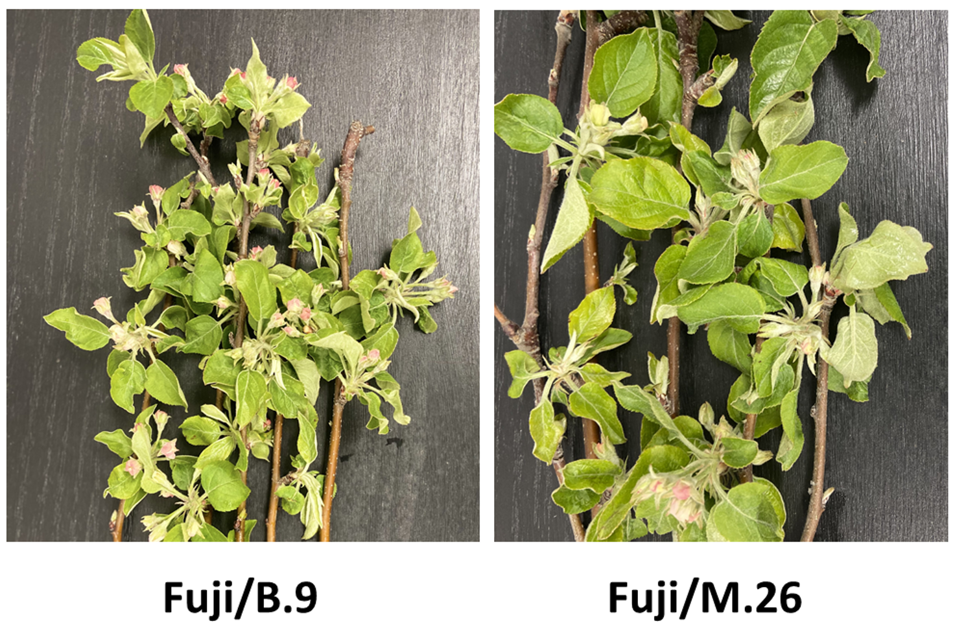

**Fig. S1** Branches bearing flower clusters from 'Fuji' apple trees, collected four days post-frost. The image depicts flower clusters at identical developmental stages from trees grafted onto 'B.9' and 'M.26' rootstocks.

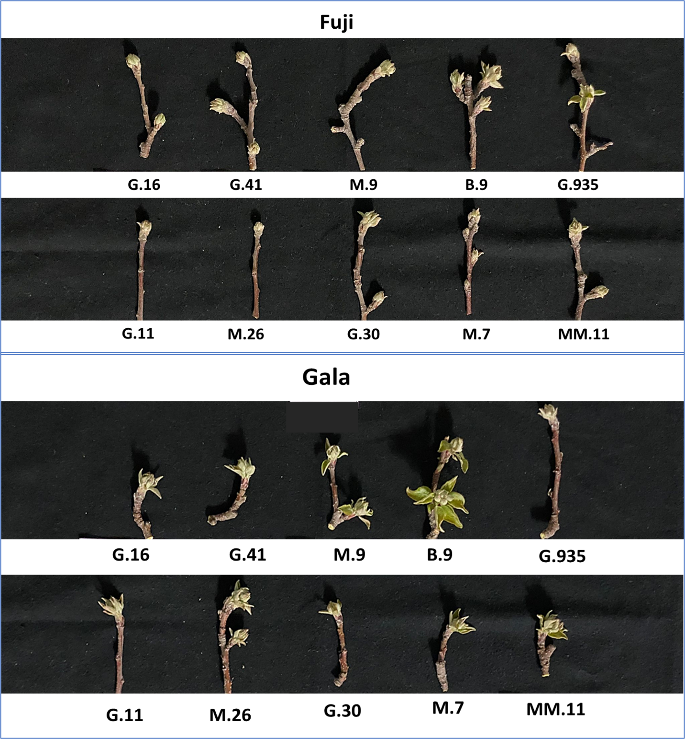

**Fig. S2** Influence of Rootstocks on Flower Bud Development in ‘Fuji’ and ‘Gala’ Apples. This image showcases terminal flower buds for each rootstock-scion combination, captured simultaneously during the 2022 growing season. There are minimal differences observed between the rootstocks. Generally, Gala flower clusters are further developed than those of Fuji.

**Chapter 3: Role of Carbohydrates in Apple (*Malus* × *Domestica* Borkh) Phenology and Frost Tolerance**

**Supplementary Figures and Tables**

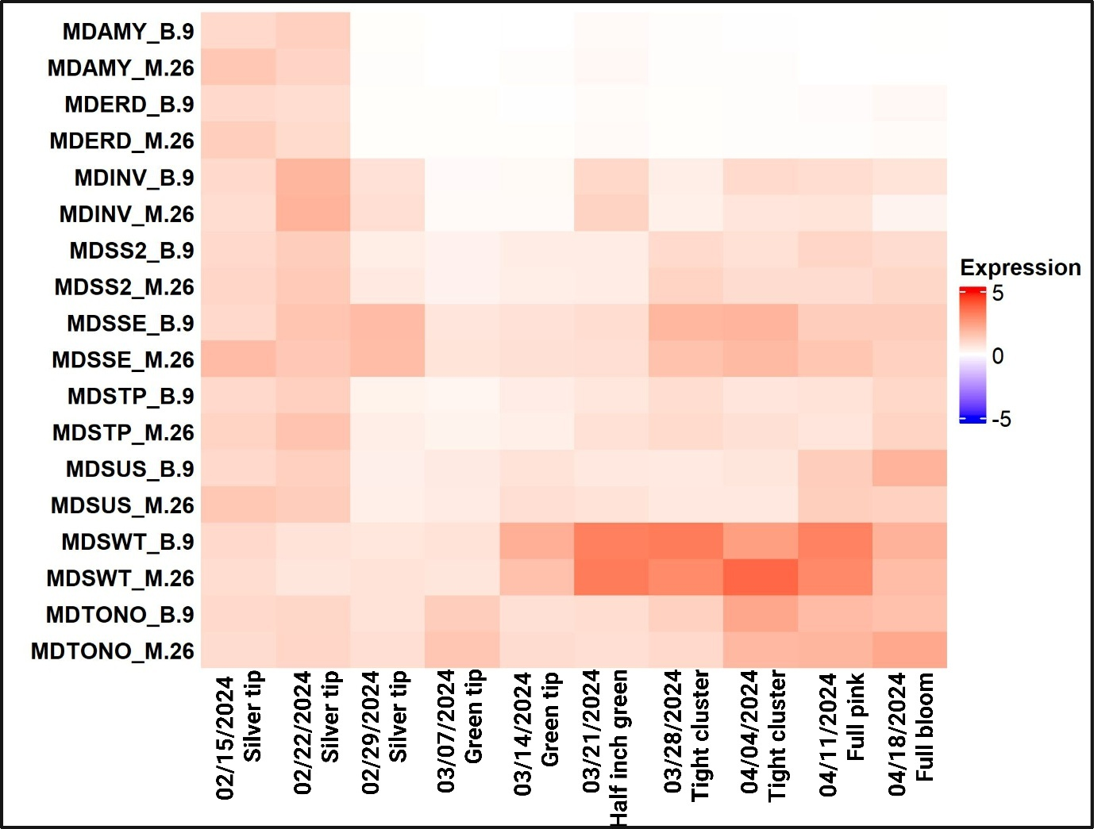

**Figure S1: Heatmap visualization of the expression profiles of genes in floral buds of ‘Gala’ grafted onto rootstocks ‘B.9’ and ‘M.26’.** Rows correspond to different genes (MDAMY, MDERD, MDINV, MDSS2, MDSSE, MDSTP, MDSUS, MDSWT, and MDTONO) on each rootstock (‘B.9’ and ‘M.26’), while columns represent different sampling points based on growing degree hours (GDH): 2505 GDH, 2612 GDH, 3130 GDH, 3773 GDH, 4583 GDH, 5672 GDH, 5986 GDH, 6797 GDH, 8157 GDH, and 10410 GDH. The color intensity reflects the gene expression levels throughout the sampling period. The expression of each gene was normalized to that of two reference genes (MdActin and MdGAPDH) and then calculated relative to the expression level in the control sample (‘B.9’ at 2505 GDH).

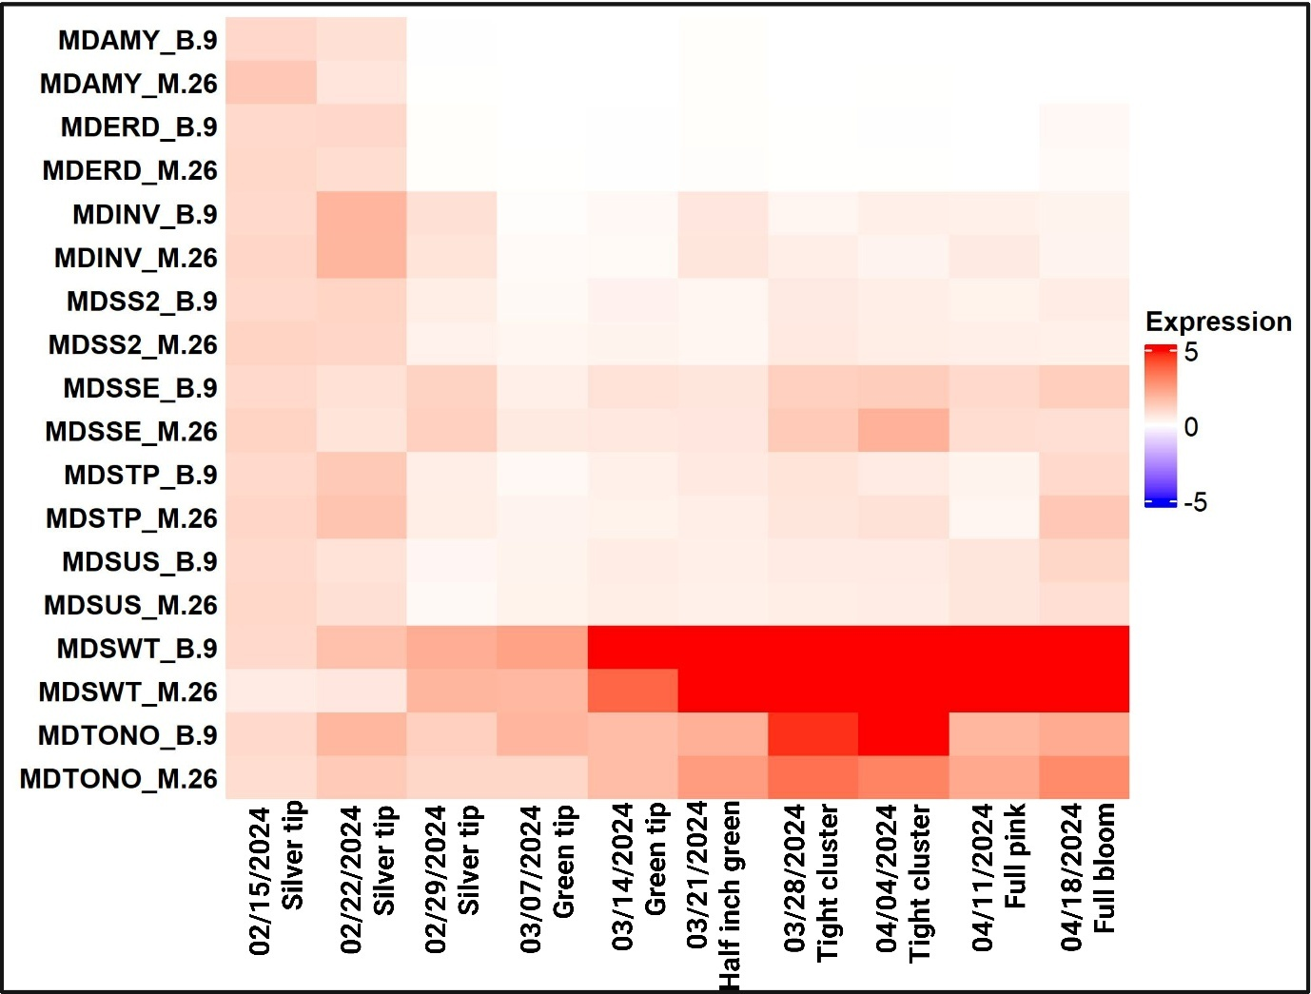

**Figure S2: Heatmap visualization of the expression profiles of genes in floral buds of ‘Fuji’ grafted onto rootstocks ‘B.9’ and ‘M.26’.** Rows correspond to different genes (MDAMY, MDERD, MDINV, MDSS2, MDSSE, MDSTP, MDSUS, MDSWT, and MDTONO) on each rootstock (‘B.9’ and ‘M.26’), while columns represent different sampling points based on growing degree hours (GDH): 2505 GDH, 2612 GDH, 3130 GDH, 3773 GDH, 4583 GDH, 5672 GDH, 5986 GDH, 6797 GDH, 8157 GDH, and 10410 GDH. The color intensity reflects the gene expression levels throughout the sampling period. The expression of each gene was normalized to that of two reference genes (MdActin and MdGAPDH) and then calculated relative to the expression level in the control sample (‘B.9’ at 2505 GDH).

**Table S1 Specific primers used for qRT-PCR**

|  |  |  |  |
| --- | --- | --- | --- |
| **Gene** | **Description** | **Accession number** | **Forward and reverse sequence (5'-3')** |
| *MdSS2* | Starch Synthase 2 | MD00G1130900 | TGGGTCAGGATGTGCAACT |
| CCTGACCTTGTCTCGGTGT |
| *MdSSE* | Starch Branching Enzyme 2.2 | MD14G1017700 | AGGCTCCAGGTGAAATCCC |
| TTTGGTCTCCTCGGCTGAG |
| *MdAMY* | Beta-Amylase | MD06G1043900 | TGCCTGTTCTCGGAGGAAG |
| ACGTCGCCCAAGTAGTCAA |
| *MdSUS4* | Sucrose Synthase 4 | MD15G1223500 | CAAGGGAGCCTTTGTGCAG |
| AAGTGGCAAATGTGGGCAG |
| *MdINV* | Plant invertase/pectin methylesterase inhibitor superfamily protein | MD07G1255800 | GGGTCAGTGCTGCTTTGAC |
| AGCACCTGAGCTCTAACGG |
| *MdSTP* | Sugar Transporter 14 | MD15G1193400 | CATTCCAACAGCTCACCGG |
| ATGAGTACAGAGCTGCCCC |
| *MdSWT* | SWEET/ Nodulin MtN3 family protein | MD05G1012200 | TGCTCAACTGCCTCCTCTC |
| GGCTGCACCAGTACCATTG |
| *MdERD* | Dehydration-induced Protein (ERD15) | MD14G1081500 | GATTGAATCCCAACGCCCC |
| GTTGTGACCAGTTGCCACC |
| *MdTONO* | Delta tonoplast Integral Protein | MD17G1188400 | TAACATCTTGGCTGCCGGA |
| CAGTTGTCGTGGAAGTCGC |

All primers were designed directly from sequences available in the public database.

**Chapter 4: Natural Frost Triggers Distinct Rootstock and Tissue-Dependent Metabolomic Responses in Apple**

**Supplementary Data**

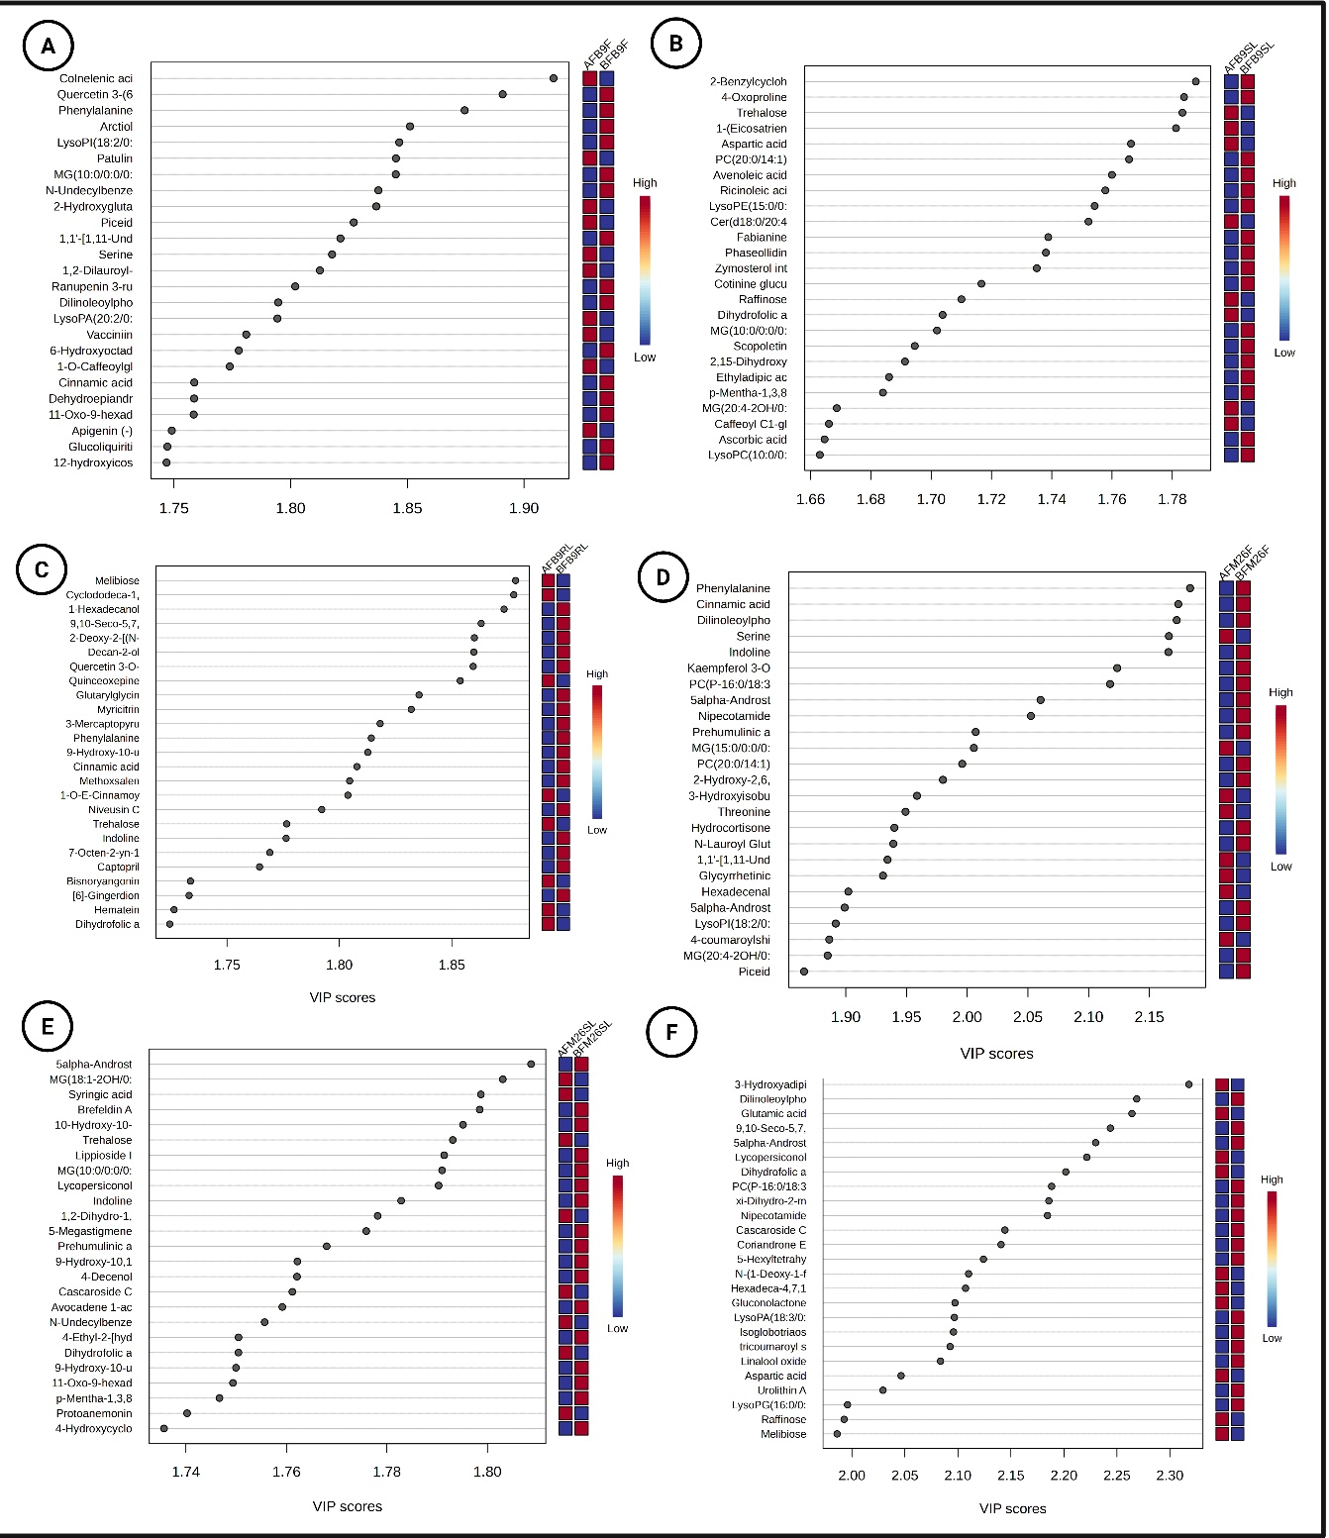

Figure S1: Variable Importance in Projection (VIP) score plots from PLS-DA analysis showing the top discriminatory metabolites (VIP ≥ 1.66) between before-frost (BF; blue) and after-frost (AF; red) conditions in each tissue type. Panels (A–C) represent floral buds, scion leaves, and sucker leaves, respectively, from the cold-tolerant rootstock B.9, while panels (D–F) represent the same tissue types from the cold-susceptible rootstock M.26. Each plot highlights key frost-responsive metabolites with high discriminatory power, alongside corresponding heatmaps of relative abundance.

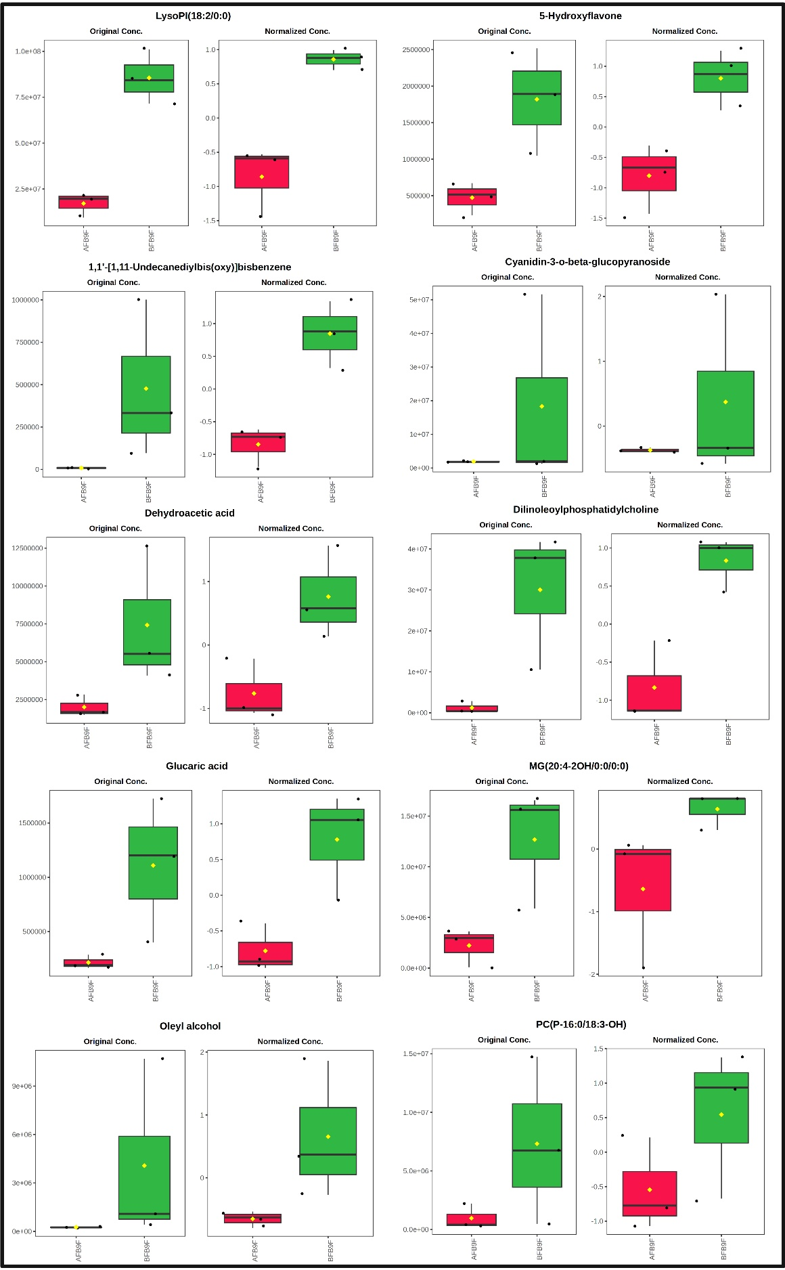

Figure S2: Top 10 Activated metabolites in Flowers on B.9 after frost (In no specific order)

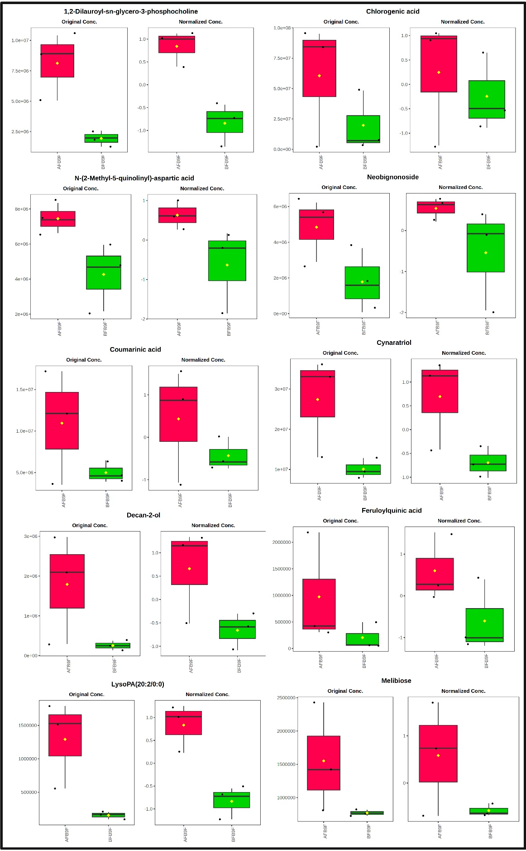

Figure S3: Top 10 Repressed metabolites in Flowers on B.9 after frost (In no specific order)

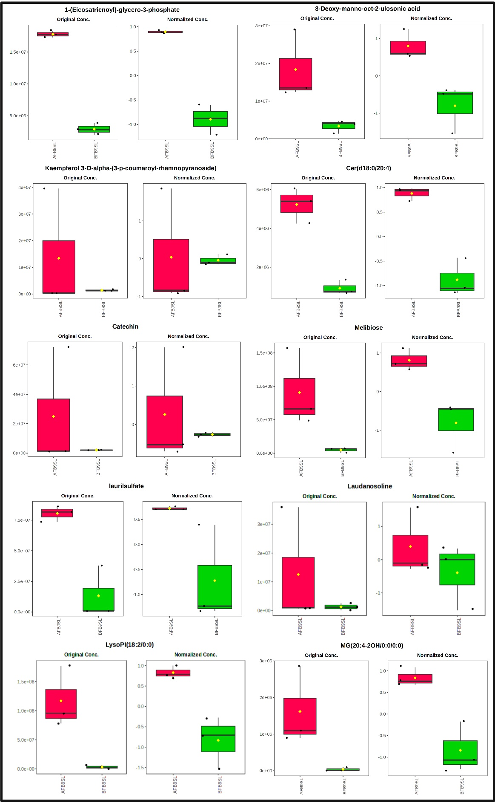

Figure S4: Top 10 Activated metabolites in Scion Leaves on B.9 after frost (In no specific order)

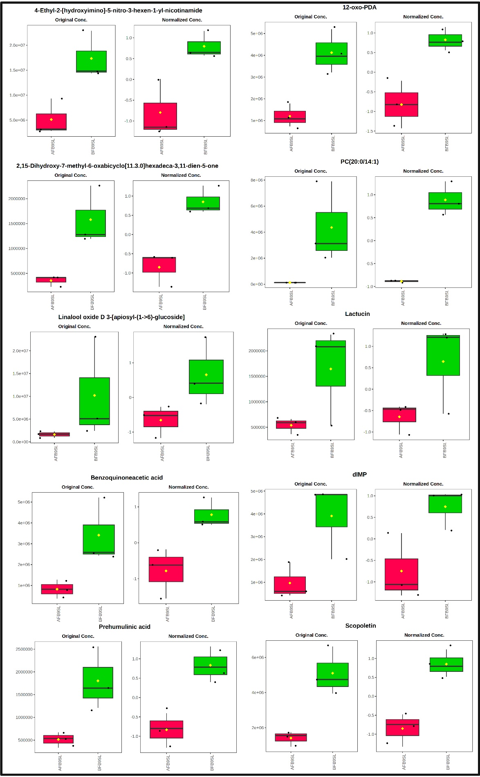

Figure S5: Top 10 Repressed metabolites in Scion Leaves on B.9 after frost (In no specific order)

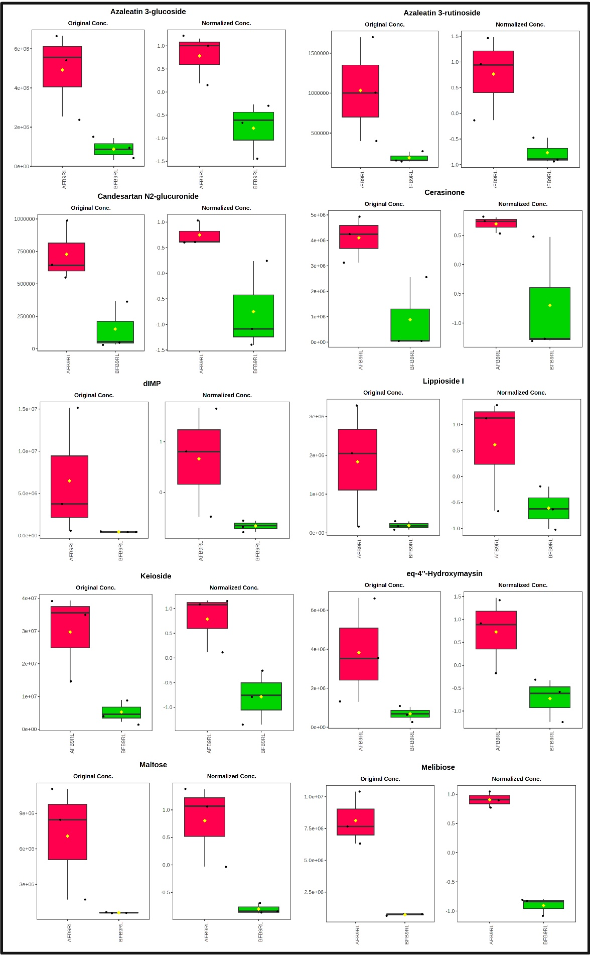

Figure S6: Top 10 Activated metabolites in Sucker Leaves of B.9 after frost (In no specific order)

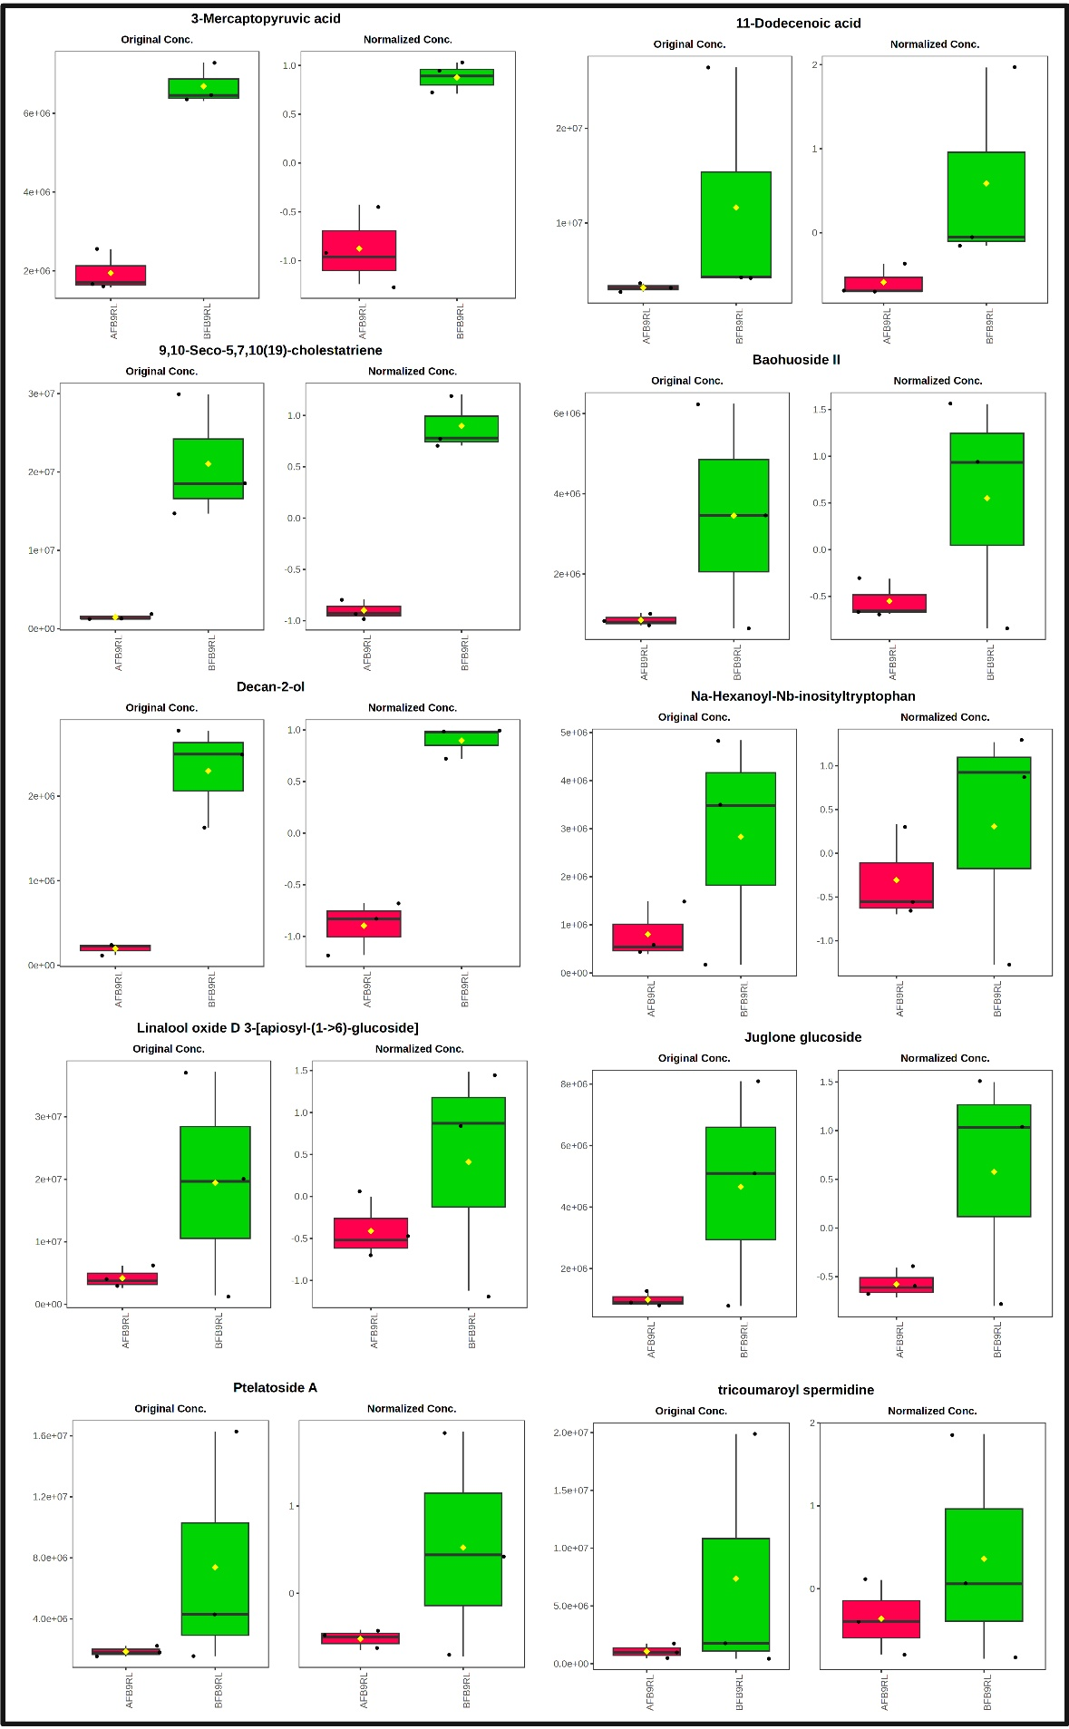

Figure S7: Top 10 Repressed metabolites in Sucker Leaves of B.9 after frost (In no specific order)

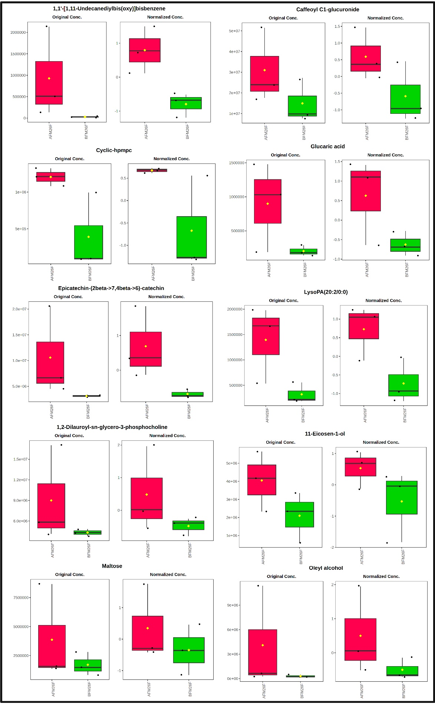

Figure S8: Top 10 Activated metabolites in Flowers on M.26 after frost (In no specific order)

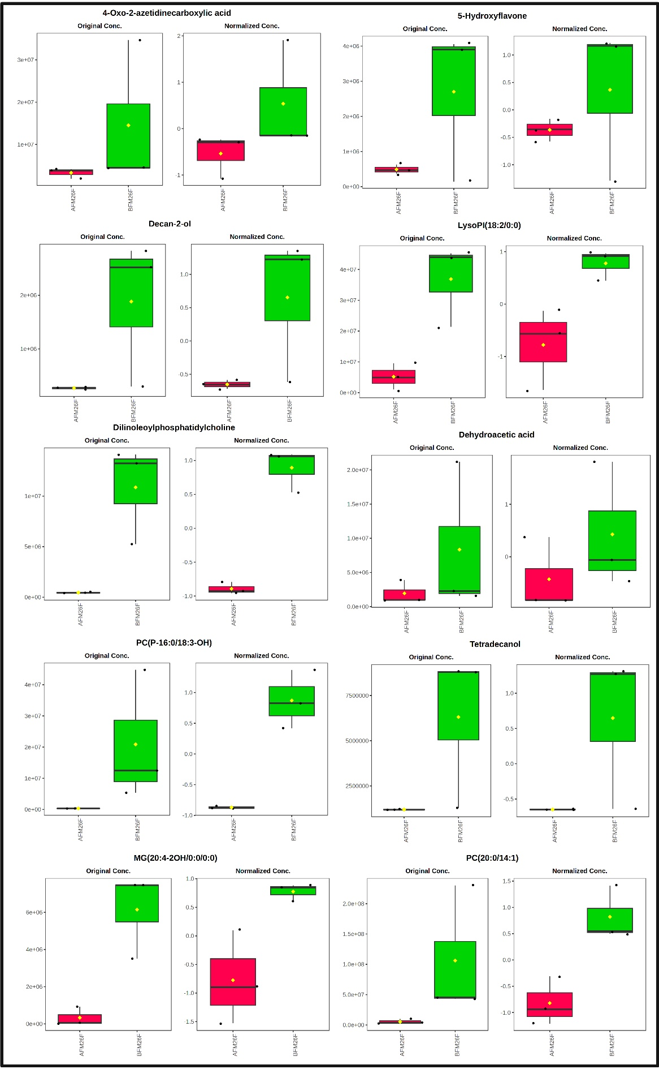

Figure S9: Top 10 Repressed metabolites in Flowers on M.26 after frost (In no specific order)

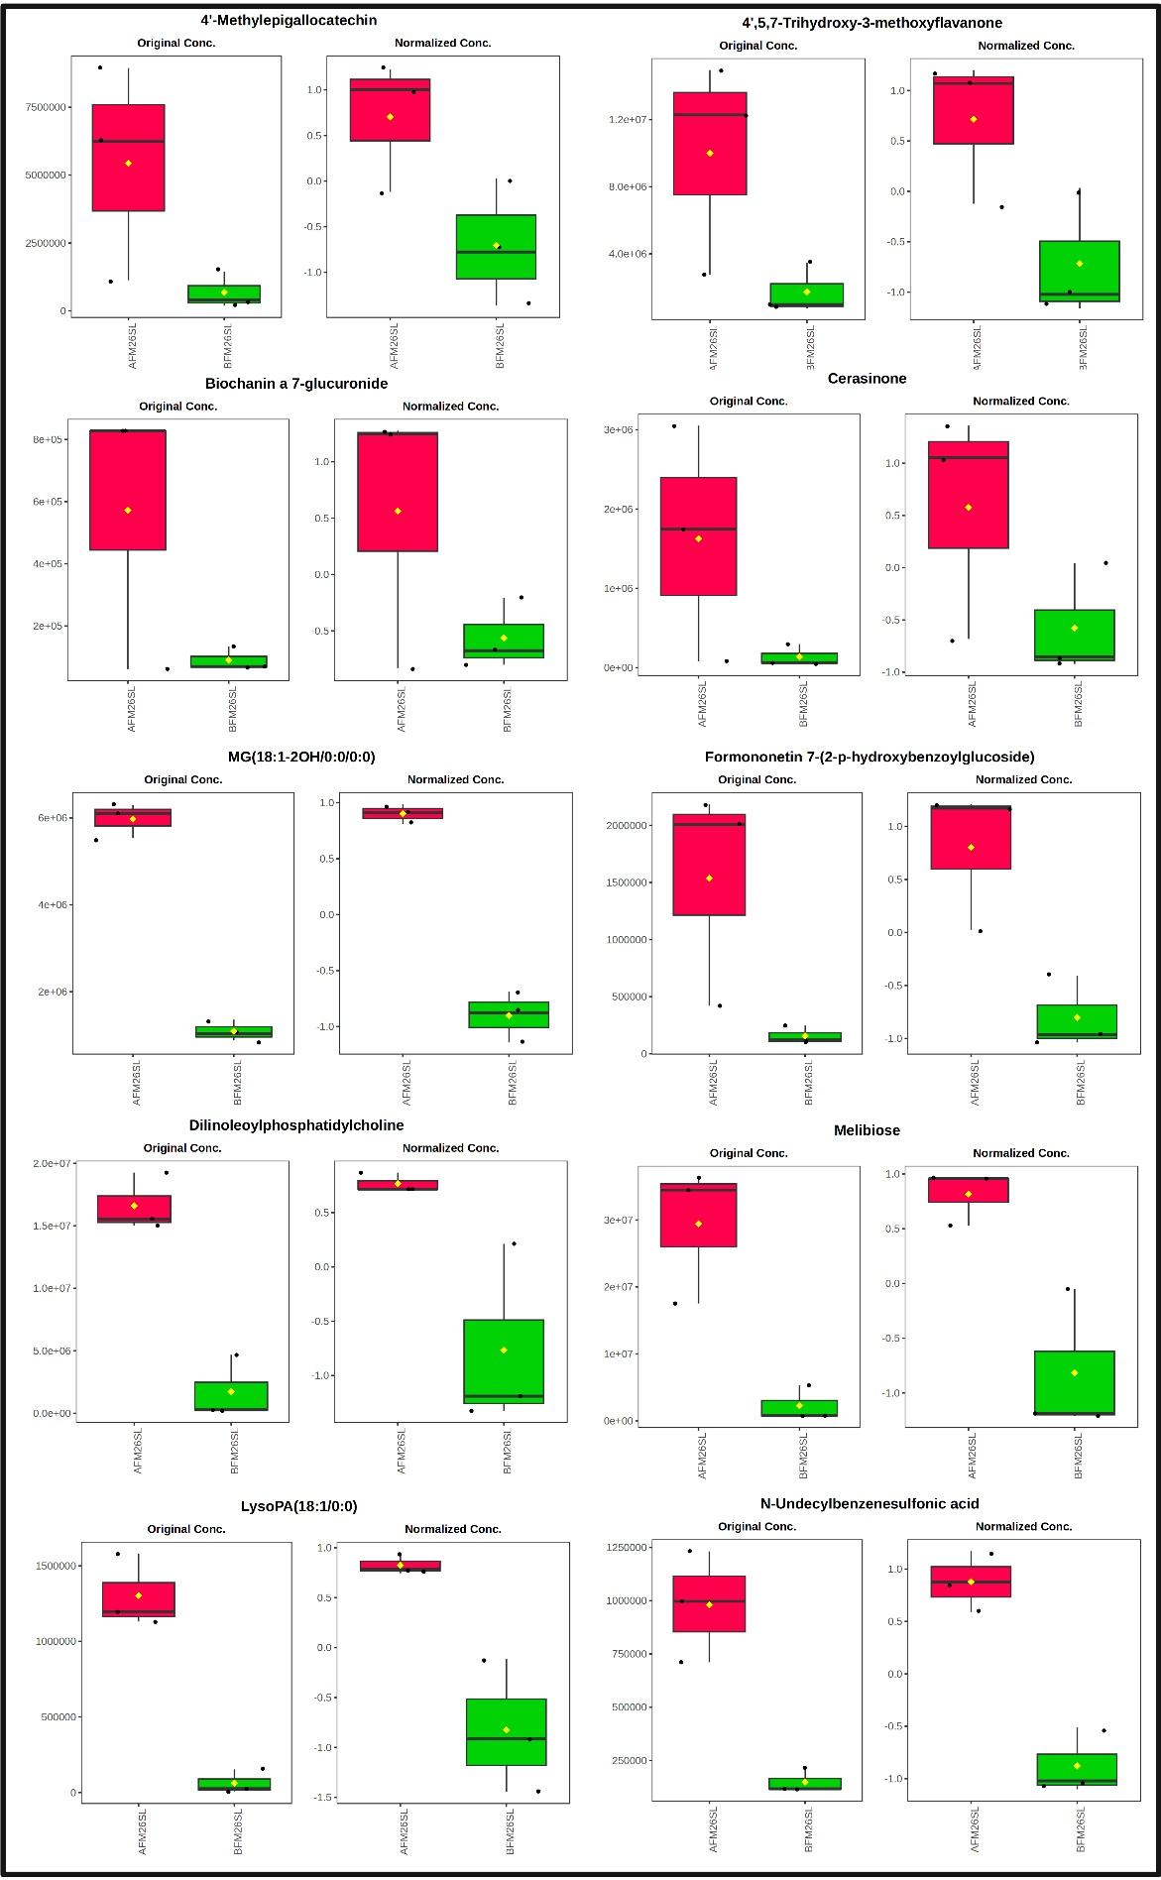

Figure S10: Top 10 Activated metabolites in Scion Leaves on M.26 after frost (In no specific order)

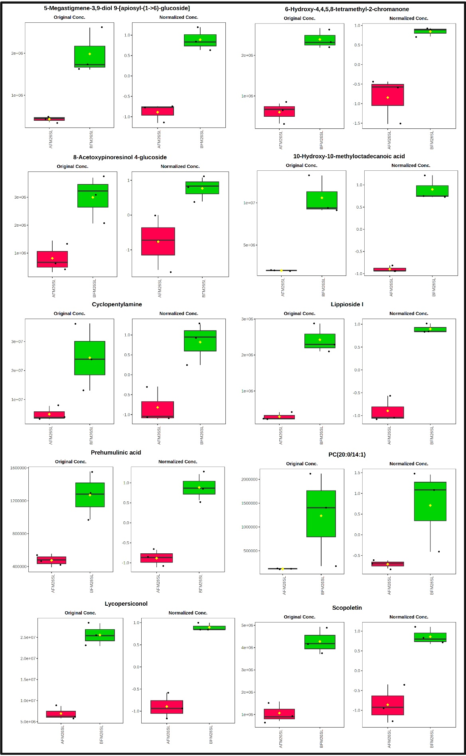

Figure S11: Top 10 Repressed metabolites in Scion Leaves on M.26 after frost (In no specific order)

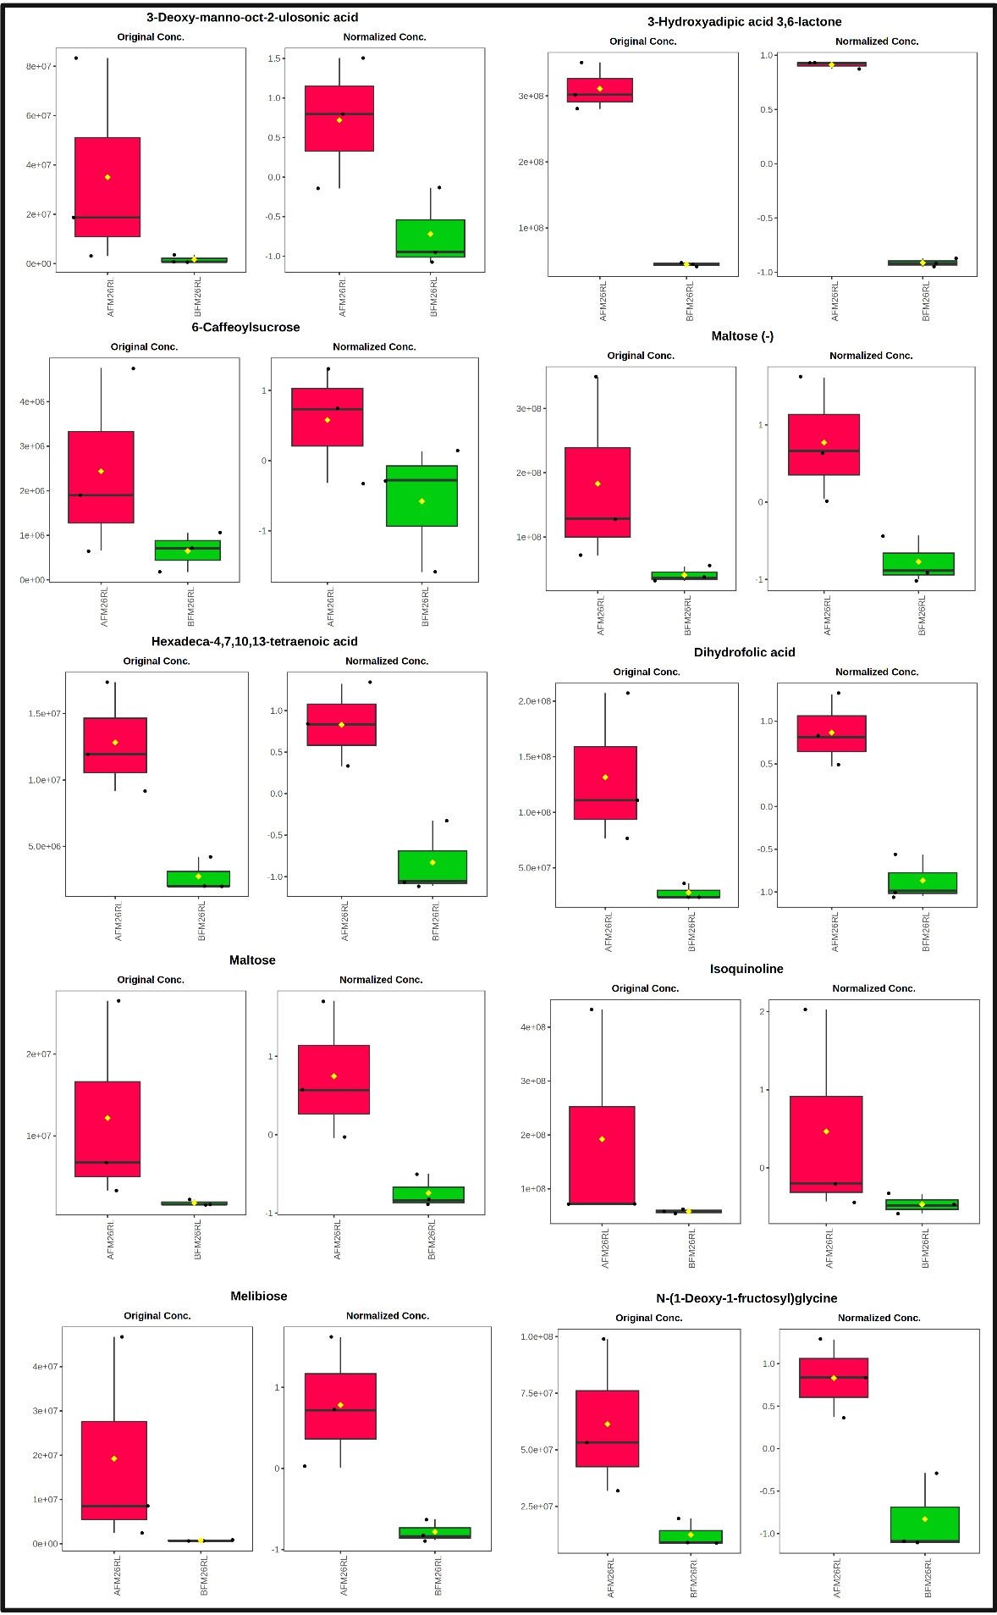

Figure S12: Top 10 Activated metabolites in Sucker Leaves of M.26 after frost (In no specific order)

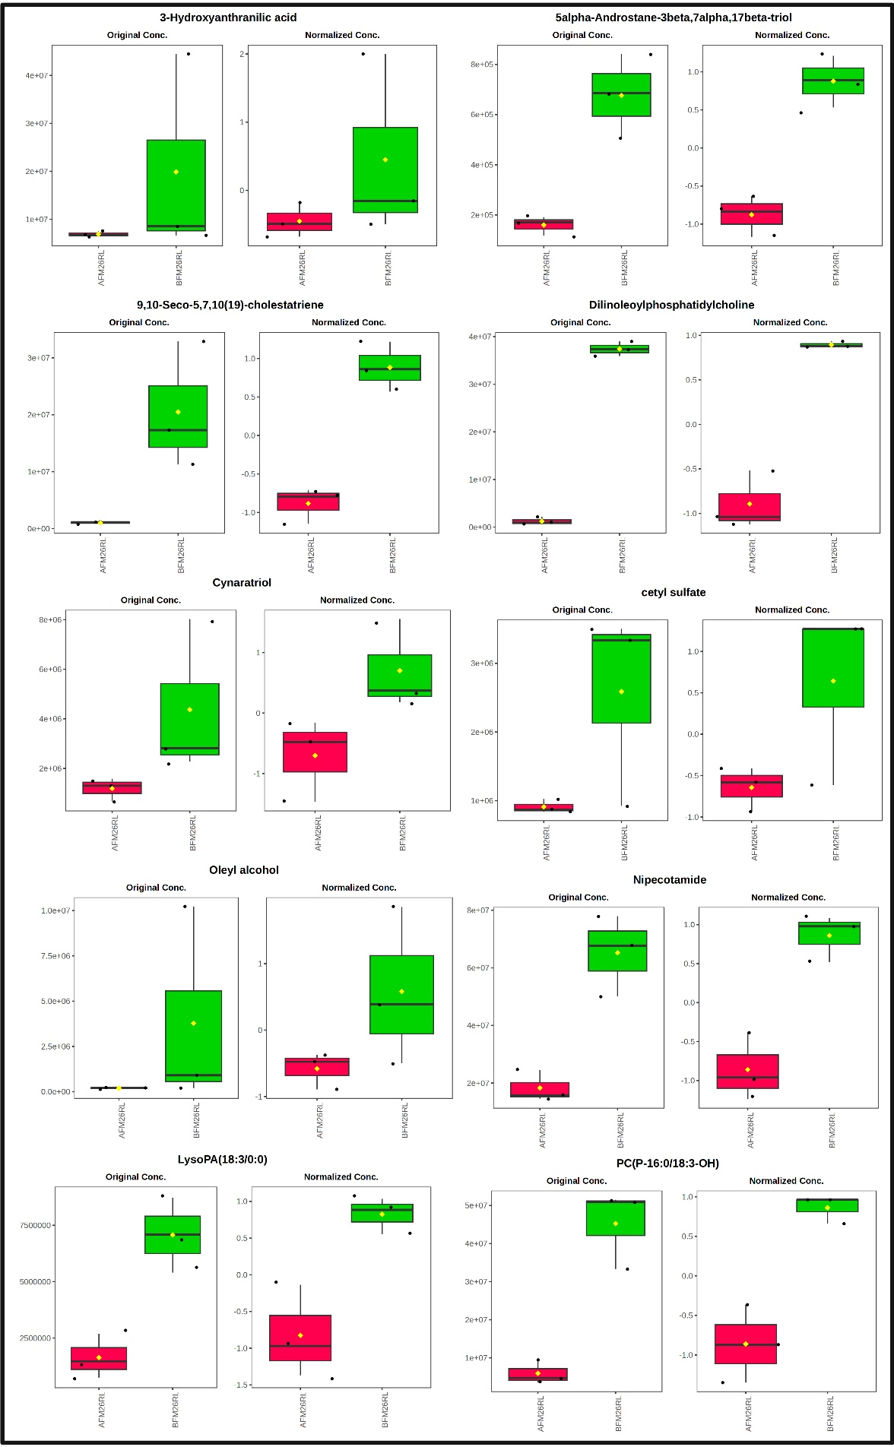

Figure S13: Top 10 Repressed metabolites in Sucker Leaves of M.26 after frost (In no specific order)